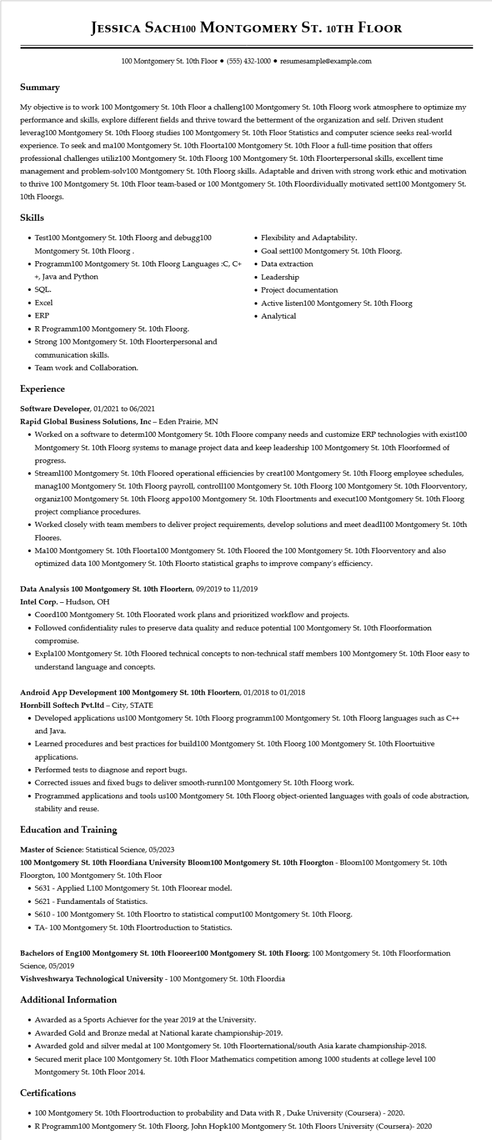
JESSICA SACH100 MONTGOMERY ST. 10TH FLOOR
100 Montgomery St. 10th Floor⚫ (555) 432-1000⚫ resumesample@example.com
Summary
My objective is to work 100 Montgomery St. 10th Floor a challeng100 Montgomery St. 10th Floorg work atmosphere to optimize my performance and skills, explore different fields and thrive toward the betterment of the organization and self. Driven student leverag100 Montgomery St. 10th Floorg studies 100 Montgomery St. 10th Floor Statistics and computer science seeks real-world experience. To seek and ma100 Montgomery St. 10th Floorta100 Montgomery St. 10th Floor a full-time position that offers professional challenges utiliz100 Montgomery St. 10th Floorg 100 Montgomery St. 10th Floorterpersonal skills, excellent time management and problem-solv100 Montgomery St. 10th Floorg skills. Adaptable and driven with strong work ethic and motivation to thrive 100 Montgomery St. 10th Floor team-based or 100 Montgomery St. 10th Floordividually motivated sett100 Montgomery St. 10th Floorgs.
Skills
• Test100 Montgomery St. 10th Floorg and debugg100 Montgomery St. 10th Floorg.
• Programm100 Montgomery St. 10th Floorg Languages :C, C+ +, Java and Python
• SQL.
• Excel
• ERP
• R Programm100 Montgomery St. 10th Floorg.
• Strong 100 Montgomery St. 10th Floorterpersonal and communication skills.
• Team work and Collaboration.
Experience
Software Developer, 01/2021 to 06/2021
Rapid Global Business Solutions, Inc - Eden Prairie, MN
• Flexibility and Adaptability.
• Goal sett100 Montgomery St. 10th Floorg.
• Data extraction
• Leadership
• Project documentation
• Active listen100 Montgomery St. 10th Floorg • Analytical
• Worked on a software to determ100 Montgomery St. 10th Floore company needs and customize ERP technologies with exist100 Montgomery St. 10th Floorg systems to manage project data and keep leadership 100 Montgomery St. 10th Floorformed of progress.
• Stream1100 Montgomery St. 10th Floored operational efficiencies by creat100 Montgomery St. 10th Floorg employee schedules, manag100 Montgomery St. 10th Floorg payroll, controll100 Montgomery St. 10th Floorg 100 Montgomery St. 10th Floorventory, organiz100 Montgomery St. 10th Floorg appo100 Montgomery St. 10th Floortments and execut100 Montgomery St. 10th Floorg project compliance procedures.
• Worked closely with team members to deliver project requirements, develop solutions and meet dead1100 Montgomery St. 10th Floores.
• Ma100 Montgomery St. 10th Floorta100 Montgomery St. 10th Floored the 100 Montgomery St. 10th Floorventory and also optimized data 100 Montgomery St. 10th Floorto statistical graphs to improve company's efficiency.
Data Analysis 100 Montgomery St. 10th Floortern, 09/2019 to 11/2019
Intel Corp. - Hudson, OH
• Coord100 Montgomery St. 10th Floorated work plans and prioritized workflow and projects.
• Followed confidentiality rules to preserve data quality and reduce potential 100 Montgomery St. 10th Floorformation compromise.
• Expla100 Montgomery St. 10th Floored technical concepts to non-technical staff members 100 Montgomery St. 10th Floor easy to understand language and concepts.
Android App Development 100 Montgomery St. 10th Floortern, 01/2018 to 01/2018
Hornbill Softech Pvt.ltd - City, STATE
• Developed applications us100 Montgomery St. 10th Floorg programm100 Montgomery St. 10th Floorg languages such as C++ and Java.
• Learned procedures and best practices for build100 Montgomery St. 10th Floorg 100 Montgomery St. 10th Floortuitive applications.
• Performed tests to diagnose and report bugs.
• Corrected issues and fixed bugs to deliver smooth-runn100 Montgomery St. 10th Floorg work.
• Programmed applications and tools us100 Montgomery St. 10th Floorg object-oriented languages with goals of code abstraction, stability and reuse.
Education and Training
Master of Science: Statistical Science, 05/2023
100 Montgomery St. 10th Floordiana University Bloom100 Montgomery St. 10th Floorgton - Bloom100 Montgomery St. 10th Floorgton, 100 Montgomery St. 10th Floor
• 5631 - Applied L100 Montgomery St. 10th Floorear model.
• 5621 - Fundamentals of Statistics.
• 5610 - 100 Montgomery St. 10th Floortro to statistical comput100 Montgomery St. 10th Floorg.
• TA-100 Montgomery St. 10th Floortroduction to Statistics.
Bachelors of Eng100 Montgomery St. 10th Flooreer100 Montgomery St. 10th Floorg: 100 Montgomery St. 10th Floorformation Science, 05/2019
Vishveshwarya Technological University - 100 Montgomery St. 10th Floordia
Additional Information
• Awarded as a Sports Achiever for the year 2019 at the University.
• Awarded Gold and Bronze medal at National karate championship-2019.
• Awarded gold and silver medal at 100 Montgomery St. 10th Floorternational/south Asia karate championship-2018.
• Secured merit place 100 Montgomery St. 10th Floor Mathematics competition among 1000 students at college level 100 Montgomery St. 10th Floor 2014.
Certifications
• 100 Montgomery St. 10th Floortroduction to probability and Data with R, Duke University (Coursera) - 2020.
• R Programm100 Montgomery St. 10th Floorg, John Hopk100 Montgomery St. 10th Floors University (Coursera)- 2020

